**Task 1: Cấu hình thiết bị mạng không dây**

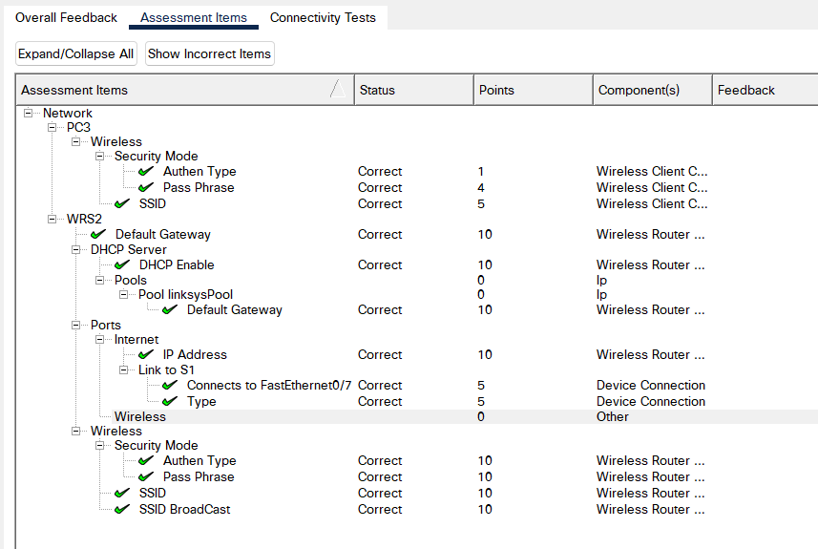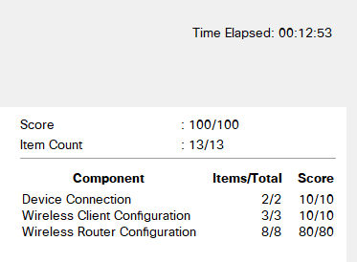

**Task 2: Cấu hình địa chỉ IP trên router**

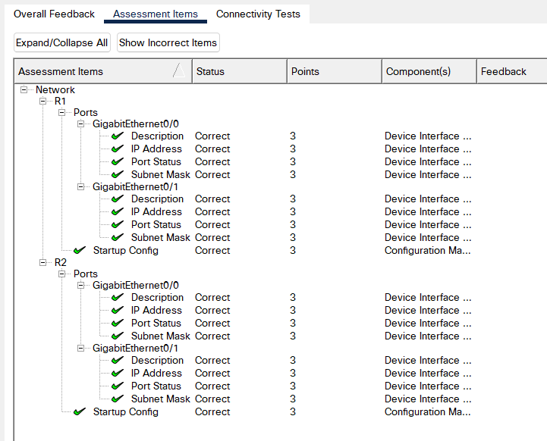

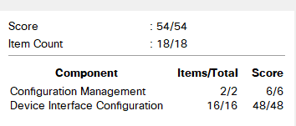

**Task 3: Áp dụng chia địa chỉ IP**

Có 8 mạng con:

* PC1, R1
* PC2, R1
* PC3, R2
* PC4, R2
* R1, R2
* 3 mạng con khác chưa dùng đến

| **STT** | **Địa chỉ mạng** | **Địa chỉ đầu** | **Địa chỉ cuối** | **Địa chỉ Broadcast** |
| --- | --- | --- | --- | --- |
| 0 | 192.168.100.0 | 192.168.100.1 | 192.168.100.30 | 192.168.100.31 |
| 1 | 192.168.100.32 | 192.168.100.33 | 192.168.100.62 | 192.168.100.63 |
| 2 | 192.168.100.64 | 192.168.100.65 | 192.168.100.94 | 192.168.100.95 |
| 3 | 192.168.100.96 | 192.168.100.97 | 192.168.100.126 | 192.168.100.127 |
| 4 | 192.168.100.128 | 192.168.100.129 | 192.168.100.158 | 192.168.100.159 |
| 5 | 192.168.100.160 | 192.168.100.161 | 192.168.100.190 | 192.168.100.191 |
| 6 | 192.168.100.192 | 192.168.100.193 | 192.168.100.222 | 192.168.100.223 |
| 7 | 192.168.100.224 | 192.168.100.225 | 192.168.100.254 | 192.168.100.255 |

| **Device** | **Interface** | **IP Address** | **Subnet Mask** | **Default Gateway** |
| --- | --- | --- | --- | --- |
| R1 | G0/0 | 192.168.100.1 | 255.255.255.224 | N/A |
| G0/1 | 192.168.100.33 | 255.255.255.224 | N/A |
| S0/0/0 | 192.168.100.129 | 255.255.255.224 | N/A |
| R2 | G0/0 | 192.168.100.65 | 255.255.255.224 | N/A |
| G0/1 | 192.168.100.97 | 255.255.255.224 | N/A |
| S0/0/0 | 192.168.100.158 | 255.255.255.224 | N/A |
| S1 | VLAN 1 | 192.168.100.2 | 255.255.255.224 | 192.168.100.0 |
| S2 | VLAN 1 | 192.168.100.34 | 255.255.255.224 | 192.168.100.32 |
| S3 | VLAN 1 | 192.168.100.66 | 255.255.255.224 | 192.168.100.64 |
| S4 | VLAN 1 | 192.168.100.98 | 255.255.255.224 | 192.168.100.96 |
| PC1 | NIC | 192.168.100.30 | 255.255.255.224 | 192.168.100.0 |
| PC2 | NIC | 192.168.100.62 | 255.255.255.224 | 192.168.100.32 |
| PC3 | NIC | 192.168.100.94 | 255.255.255.224 | 192.168.100.64 |
| PC4 | NIC | 192.168.100.126 | 255.255.255.224 | 192.168.100.96 |

